**Medical Benefits**

<https://speakingofresearch.com/facts/medical-benefits/>

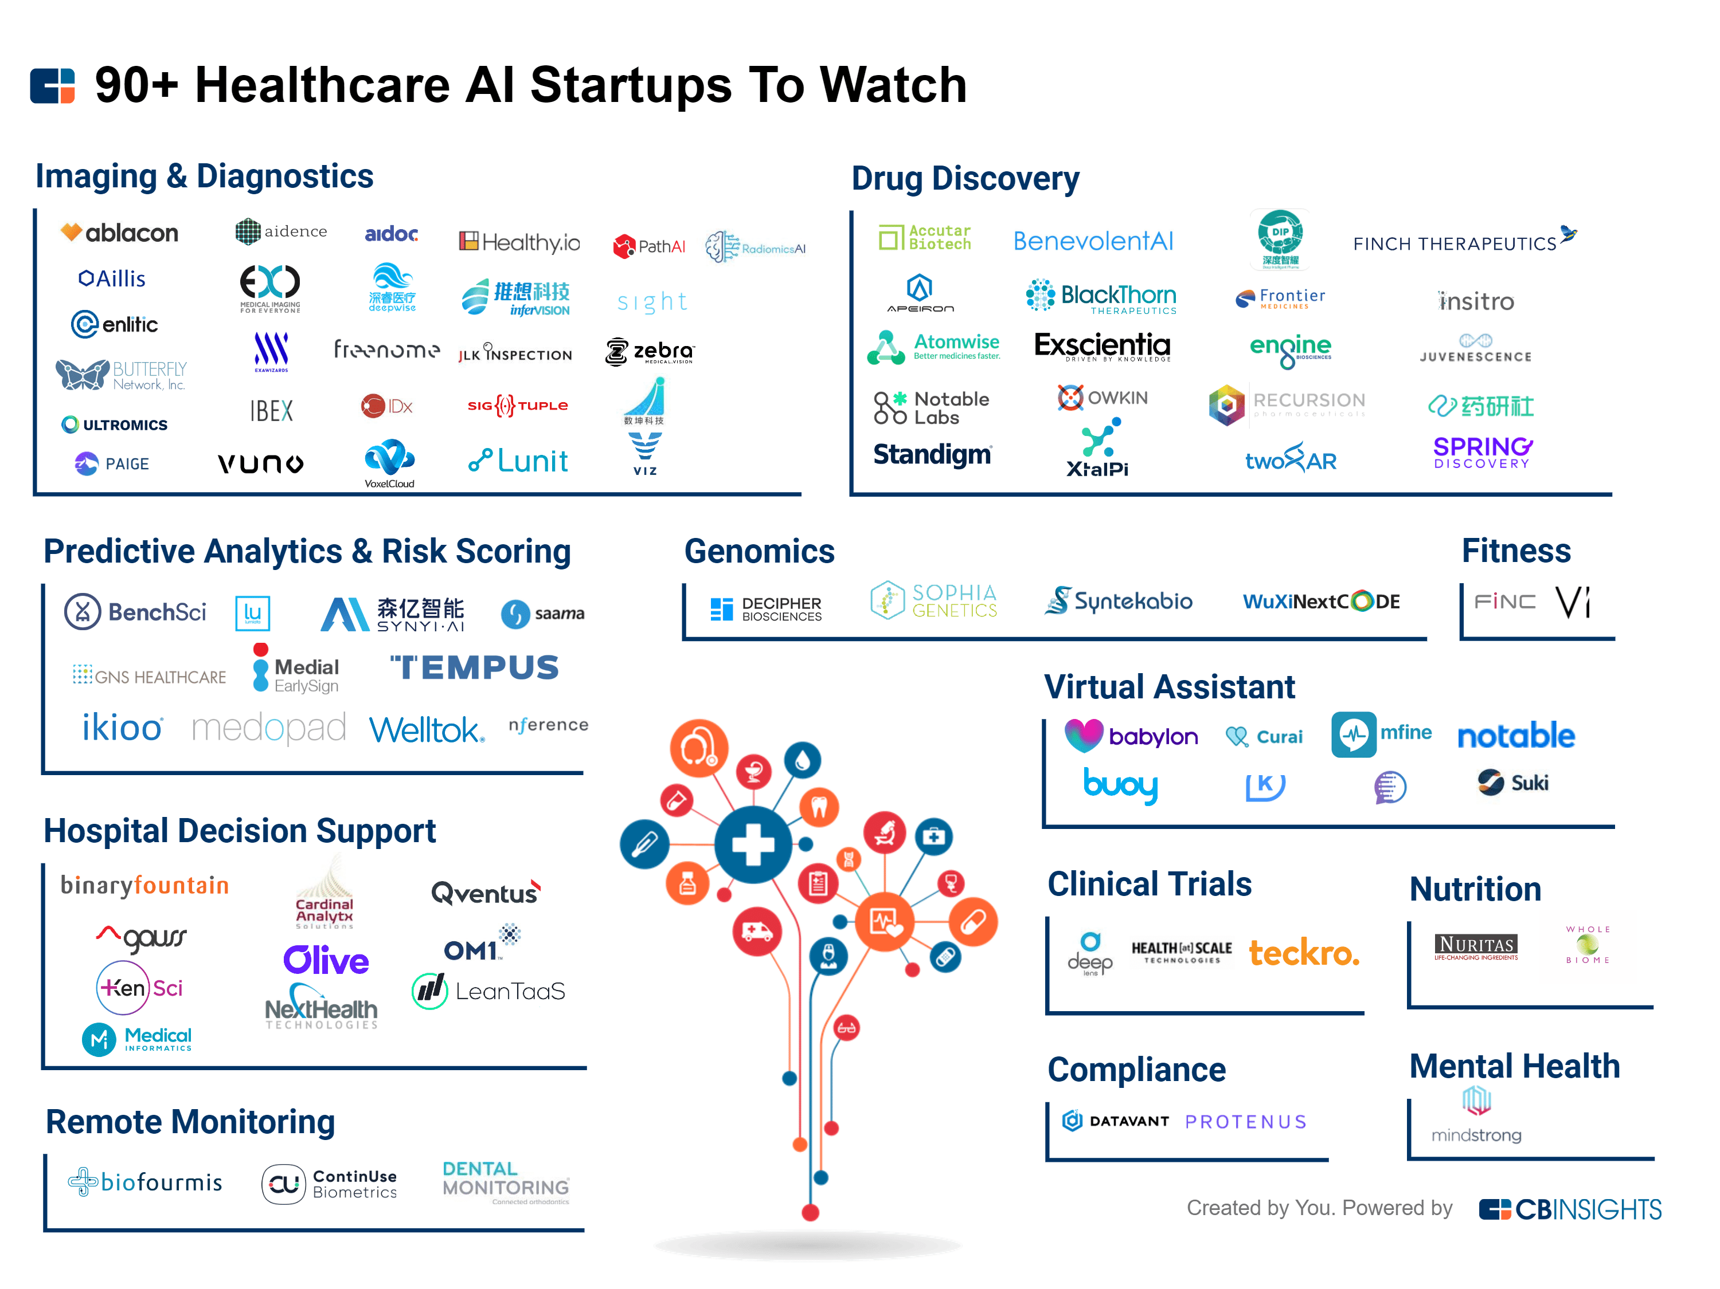

<https://medicalfuturist.com/fda-approvals-for-algorithms-in-medicine/>

<https://www.nih.gov/sites/default/files/about-nih/public-trust/clinical-trials-infographic.pdf>

